Sprint Report 2 — Sprint 2 (Scrum Master Sprint)
Project: Chuds and Chads Casino
Sprint: Sprint 2
Sprint Dates: 01/27/2026-02/02/06/2026
Scrum Master: Caleb Blevins (CB)
Submitted by: Caleb Blevins (CB)

Exported Trello/Planner Board (Required)

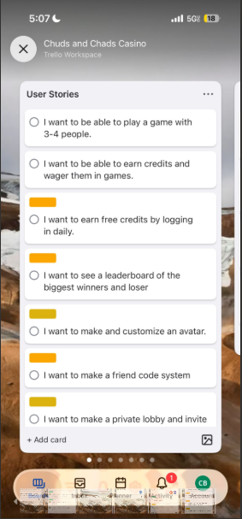
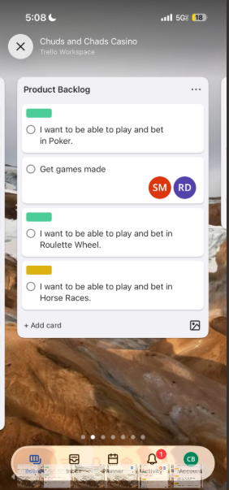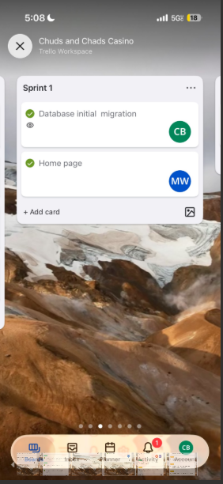
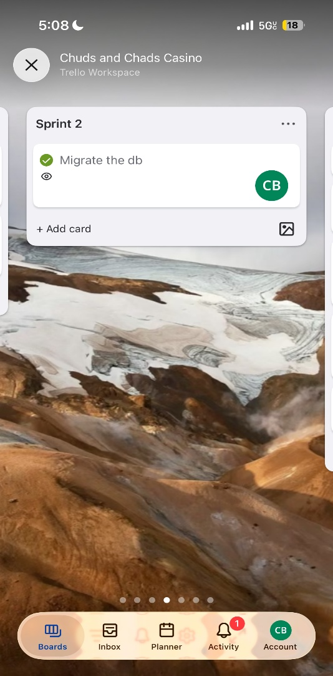

2) Sprint Goal
Sprint Goal: Complete the database migration so the project can persist and retrieve data reliably, enabling Sprint 3 work on authentication and storing accounts/credits in the migrated database.

3) PBIs Chosen + Selection Rationale
PBIs chosen for Sprint 2
- Migrate the db (Owner: CB)
How PBIs were chosen (decisions/actions):
- Selected based on dependency priority: without a migrated working database, login/register, credits, wagers, leaderboard, and avatar customization cannot be persisted.
- Chosen to reduce technical risk early and unblock the rest of the roadmap.
Velocity / estimation approach
- Still not using formal story points consistently, so tracking velocity by PBIs + tasks completed.
- Sprint 2 is a “critical-path sprint” focused on one major infrastructure deliverable.

4) Sprint Planning Activity Summary
- As Scrum Master, facilitated sprint planning and ensured the database migration was the top priority.
- Confirmed team understanding of what “migrated” means: schema created, data moves/works, app connects cleanly, and basic queries succeed.
- Identified follow-on sprint impacts: login/register integration will extend into the next sprint if DB testing or schema changes occur late.

5) Tasks Planned
PBI: Migrate the db
- Task A: Finalize target DB choice + schema
- Task B: Execute migration (tables/relationships/data mapping)
- Task C: Update app configuration/connection + validate queries
- Task D: Smoke test integration (basic CRUD checks and sanity checks)

6) Task Details— Sprint 2
Task Owner | Task Title | Task Description | Status | Challenges Faced | Lessons Learnt | Planned Time | Actual Time
CB | Finalize schema + DB setup | Created/validated final schema structure needed for current scope; ensured DB created properly. | Completed | Tight dependency timing with login/register pages | Lock schema MVP first; add new features after core pipeline works | 4 hrs | 5 hrs
CB | Run database migration | Migrated database to the new system and confirmed structure/data mapping is correct. | Completed | Migration took longer than planned (pushed completion to Tuesday earlier in sprint flow) | Underestimate risk = schedule slip; plan buffer on infra tasks | 6 hrs | 9 hrs
Matt | App connection + config updates | Updated project configuration to point to migrated DB; verified app can connect. | Completed | Environment differences and connection string tweaks | Standardize configuration + document setup steps | 3 hrs | 4 hrs
Sam | Validation + smoke tests | Verified expected tables exist and basic read/write operations work; ensured no breaking build issues. | Completed | Debugging time + verifying migration correctness | Always add a repeatable test checklist for infra deliverables | 2 hrs | 3 hrs

7) Roadblocks
- Timing risk: migration completion happened later than ideal, compressing time for the team to immediately integrate login/register into the migrated DB.
- Impact: login/register work started but may extend into Sprint 3 due to late-week completion of dependent pages.

8) Sprint Review (4 pts)
Was the sprint goal achieved? Yes — the database was migrated.
Why: The migration PBI was completed and validated with basic checks, unblocking authentication and feature persistence work.
Acceptance testing by Product Owner (feedback):
- PO confirmed DB migration is complete and aligned with upcoming features.
Adjustments planned (Product):
- Sprint 3 focus: finish login/register logic, ensure accounts save into DB, and begin integrating credits tracking.
Revised Definition of Done (DoD):
- For infrastructure PBIs (like DB migration), “Done” requires:
  - Verified connection works on at least one teammate machine,
  - Migration steps documented in README,
  - Basic test checklist completed (schema present + sample CRUD),
  - Trello updated + commits pushed.
Sprint review summary:
- Sprint 2 delivered the critical backend milestone: a migrated, connectable database foundation.

9) Sprint Retrospective
What went well
- Strong communication; team aligned on priority and the DB work was delivered.
- Everyone stayed coordinated around dependencies.
What didn’t go well
- Migration completion timing caused downstream work (login/register integration) to start later than planned.
Adjustments planned (Process)
- Add buffer for high-risk infrastructure tasks.
- Use story points and/or explicit risk flags (“high-risk/medium-risk”) on cards.
- Require at least one “integration day” at end of sprint for dependent work to validate.
Sprint retrospective summary
- Sprint succeeded, but the team needs stronger estimation/risk management for backend milestones.
Team velocity tracked
- Sprint 2 completed 1 PBI (“Migrate the db”).
- Next sprint: start tracking story points to report velocity numerically.

10) Backlog Grooming Activity Summary
Grooming activities
- Reviewed Product Backlog and User Stories related to credits, wagering, leaderboard, avatar customization, friend code, and private lobby.
- Identified that several of these require additional tables/relationships and should be staged after authentication.
PBIs added/removed/reprioritized
- Reprioritized “login/register integration with DB” as immediate next sprint work.
- Noted upcoming enhancement work: loot crates + clothing inventory for avatar customization (requires DB expansion).
Definition of Ready (DoR)
- Story + acceptance criteria written
- DB dependencies identified (new tables/fields listed)
- Owner assigned + estimate given
- Clear test expectation (what proves it works)

11) Two Daily Scrum Meeting Summaries
Daily Scrum #1 (Sprint 2 — early week)
- CB (Scrum Master): DB migration in progress; schema finalization + migration steps underway. Next: complete migration and validate connection. Blockers: none.
- MW: Continued UI/page work; ready to plug into DB once migration stable. Next: help test DB integration.
- SM: Advanced game logic outline; waiting on DB/auth to hook credit wagering. Next: implement one game logic module skeleton.
- LL: UI support + component structure; preparing for auth flows. Next: assist with UI for login/register and nav.
- RD: Requirements/design for game wagering/credits; waiting on DB. Next: help test and document game flow needs.
Daily Scrum #2 (Sprint 2 — later week)
- CB: Migration completed and connection validated; updated project config and ran smoke tests. Next: support login/register DB integration + start planning DB expansion for loot crates/clothes.
- MW: Ready to start integrating UI pages with authentication once DB is stable. Next: coordinate with CB on storage/queries.
- SM: Began implementing initial game logic components in parallel; next: connect wager results to credits once auth exists.
- LL: Assisted with UI structure and planning for avatar customization layout. Next: help implement supporting pages once data model exists.
- RD: Documented needed fields for credits/wagers and leaderboard approach. Next: assist with testing and future DB schema requirements.

12) GitHub Repo Link
Repo: https://github.com/SamMccorke1/SE2-Project---Casino.git
13) Attendance
Sprint 2 attendance (two class sessions):
- CB: present during Sprint 2 workdays
- MW/SM/LL/RD: There for most of sprint 2

